**Dragonfly Max Information for Athletic Eligibility**

Players new to MB athletics:

1. Create a Dragonfly Max account. How to create an account (for players who are new to MB athletics) can be found at the bottom of page 2.
2. After you have created a DF account - follow the instructions under the Dragonfly Max 19-20 Prep section highlighted in blue below.

Returning Players:

1. Log into the Dragonfly Max account you created last year (18-19) **DO NOT CREATE A NEW ACCOUNT**
2. The 19-20 prep Instructions are below (highlighted in blue). Complete all items listed under 19-20 prep section.

**Dragonfly Max 19-20 Prep:**

**Returning Players (& players new to MB athletics- create your Dragonfly Max account first):**

* Log on to your Dragonfly Max account ( <https://www.dragonflymax.com/>  -   go to the website on your desktop or phone – do not use the app to complete the 19-20 prep)
* Go to the Athlete Profile page
  + Then Things to Do  -  Prep 2019-2020
* Click on Get Started
  + cid:image005.jpg@01D4FC30.CC476DD0

After you click on Get Started the 19-20 Prep items that need to be completed will appear (complete all items NOW):

* **Medical & Demographic Info for 19-20** 
  + Complete this section if you are new to Dragonfly Max
  + *Update* this section if you created a Dragonfly Max account during the 18-19 school year
* ***Pre-participation Physical Evaluation form*** 
  + *Complete this is page- this one of the physical form*
* **Physical Exam** 
  + Completed by physicians at MBHS/MBJH physical day ( if you attended the MB system physical day in April)

OR

* + If you did not attend physical day take this form to your personal physician to complete and upload to Dragonfly Max
* **AHSAA Concussion form**
  + (19-20 form) all athletes and a parent need to sign
* **AHSAA Participation Waiver**
  + (19-20 form) all athletes and a parent need to sign
* **NFHS Sportsmanship**
  + All new athletes must complete this course and upload their certificate to Dragonfly Max
  + All returning MB athletes – this form will already be online on dragonfly or on file in the athletic office
* **Birth Certificate**
  + All new athletes should upload their birth certificates to Dragonfly Max
  + All returning MB athletes – your BC will already be online on dragonfly or on file in the athletic office
* When all items are completed the athlete’s 19-20 check list will look like this:

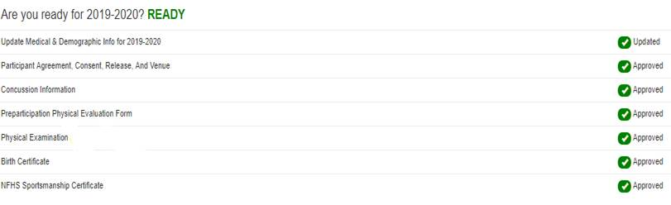

New to MB athletics: New players need to go to <https://www.dragonflymax.com/>  -   go to the website on your desktop or phone to create a new Dragonfly Max account. Instructions are below: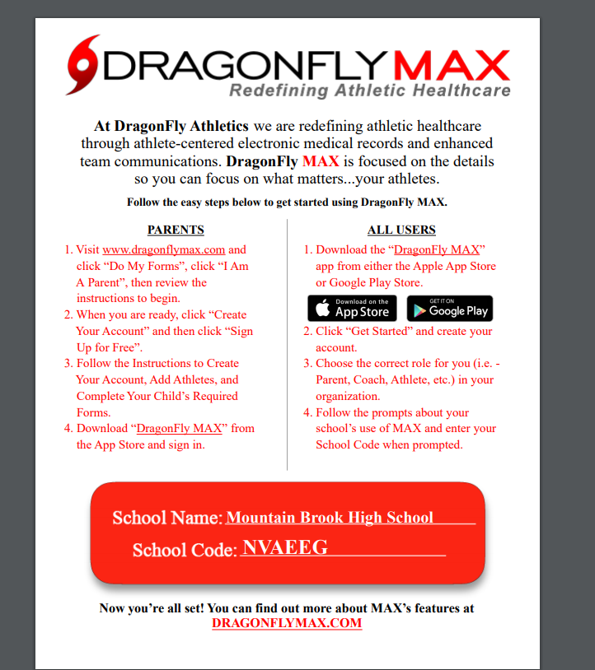

Questions- contact Michelle O’Connor [oconnorm@mtnbrook.k12.al.us](mailto:oconnorm@mtnbrook.k12.al.us)